**Key Features**

• Load games and save files in a flash with read and write speeds of up to 5,000/4,200 MB/s.¹  
• Save the power for your performance. Get power efficiency all while experiencing up to 70% improved performance per watt over the 970 EVO Plus.²  
• Ramp things up without overheating the system. Samsung’s fine-tuned controller and heat spreading label deliver effective thermal control to avoid performance drops mid-project.

Storage

**2TB**

$119.99- Current Price~~$239.99- original price~~

**Save $120.00**

**1TB**

$74.99- Current Price~~$119.99- original price~~

**Save $45.00**

**VIP Advantage**

**VIP Advantage membershipLearn more**

* 2 Year Samsung Care+ (without Theft and Loss)
* Exclusive Discounts & Early Access

To select this option, please sign in or create a Samsung account

**Premium Benefits**

**$149.99/yr**

**Delivery & professional services**

Availability for:

96928

Delivery

**Delivery**

Not available



**In-Store Pickup**

Not available

This product is currently not available in your area.

**Choose your purchase option**

Questions? Ask a Financing Expert

**One-time Payment**

**$119.99**

**Samsung Financing**(Pay Monthly)

**$10.00/mo**

for**12 mos ⊕σ**

**Pay in 4 Installments**

**$30.00**

**every two weeks σπ**

**One-time payment**

Pay with your credit card, debit card or a pay app. Excludes taxes and shipping.

**990 EVO Gen4 NVMeᵀᴹ SSD 2TB$119.99**

**Total**

**$119.99~~$239.99- original price~~**

**You Saved Today$120.00**



**Log in now to earn up to 1.5% back in Samsung Rewards Points**

**Add to cart**

[**Where to buy**](https://www.samsung.com/us/computing/memory-storage/solid-state-drives/990-evo-nvme-ssd-2tb-mz-v9e2t0b-am-buy)

Supported payment types:

Credit CardPayPal Venmo Checkoutamazonpaygooglepay

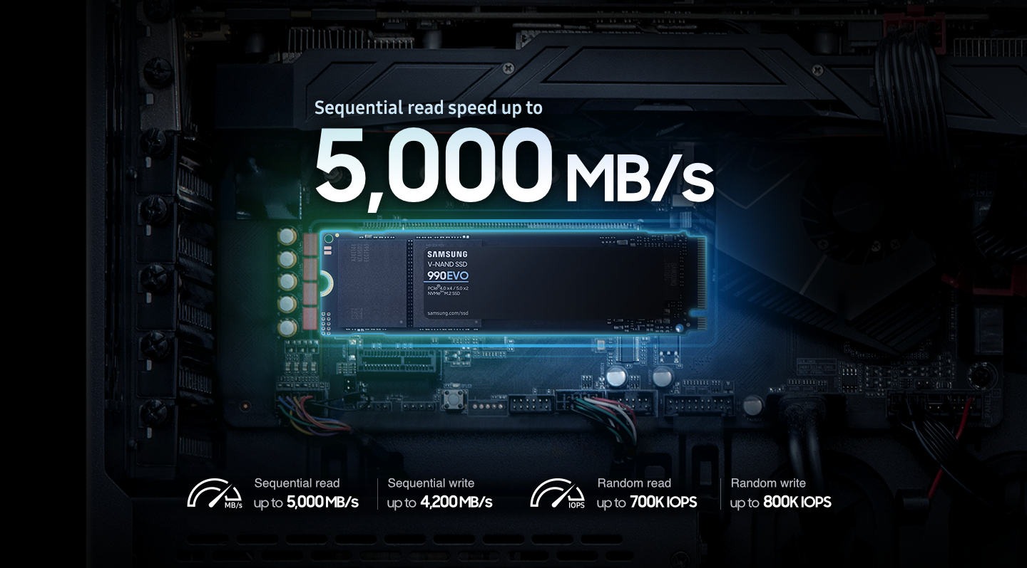

**Give every task a boost**

Read/Write Speeds up to 5,000/4,200 MB/s

Load games and save files in a flash. Bring power to your productivity with read and write speeds of up to 5,000/4,200 MB/s.¹ The 990 EVO provides continuous speed to keep you going.

*1Sequential and random write performance was measured with Intelligent Turbo Write technology being activated. Intelligent Turbo Write operates only within a specific data transfer size. Performance may vary depending on SSD’s firmware, system hardware & configuration and other factors. For detailed information, please contact your local service center.  
*Test system configuration: AMD Ryzen9 7950x 16-Core Processor CPU@4.5GHz, DDR5 4800MHz 16GBx2 (PC5-38400), OS-Windows 11 Pro 64bit, Chipset - ASRock X670E Taichi  
*To maximize the performance of the 990 EVO, please check whether your system supports PCIe® 4.0 or PCIe® 5.0 at the Intel or AMD website.*



**It's a power move**

Power Efficiency

Save the power for your performance. Get power efficiency all while experiencing up to 70% improved performance per watt over the 970 EVO Plus.² It makes every move more effective with less power consumption overall.

*²970 EVO Plus Sequential Read/Write - 636/550 MB/Watt, 990 EVO Sequential Read/Write - 1,020/933 MB/Watt based on test result of the 1TB capacity model.*

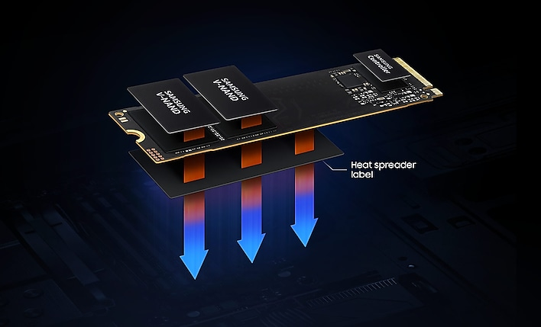

**Keep your cool**

Smart Thermal Control

Now you can ramp things up without overheating the system. Samsung’s fine-tuned controller and heat spreading label deliver effective thermal control to avoid sudden performance drops mid-project. It cools things down even when things are running high, so your hard earned checkpoints are saved.



**Latest PCIe technology**

PCIe 4.0 and Gen 5.0

Optimized to support the latest technology for SSDs—990 EVO is compatible with PCIe 4.0 x4 and PCIe 5.0 x2. This means you get more bandwidth and higher data processing and performance.

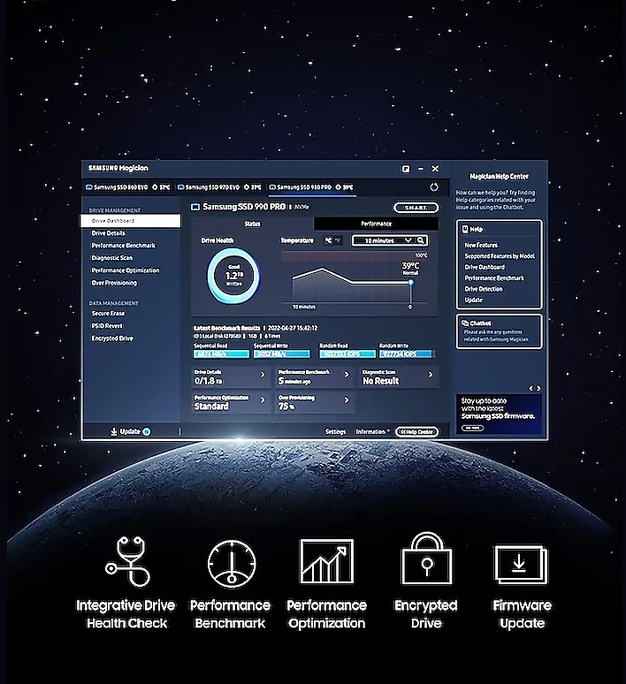

**Works like magic**

Always Up-to-Date via Magician Software

It’s not hocus-pocus. Your 990 EVO SSD performs like new with the always up-to-date Magician Software. Stay up to speed with the latest firmware updates, extra encryption and continual monitoring of your drive health–it works like a charm.

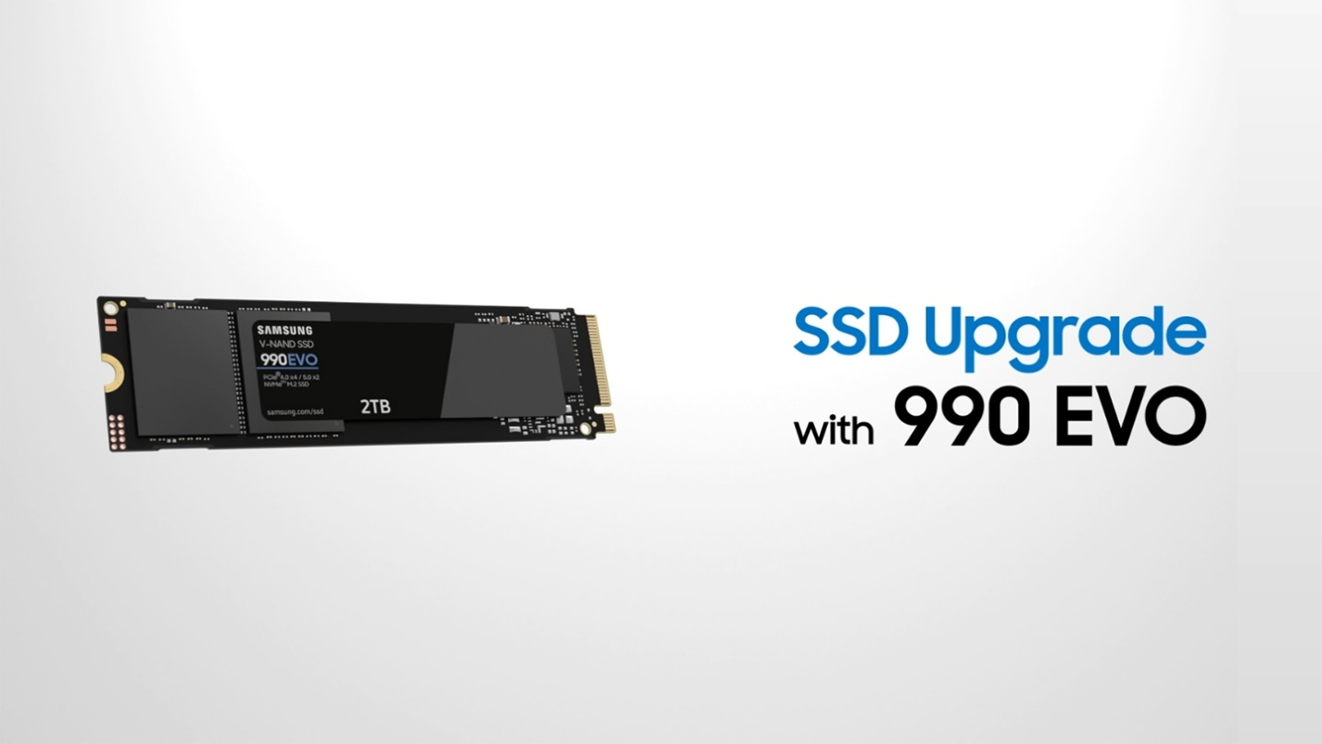

**Unlock the power of Samsung SSDs in a few easy steps**

Follow these simple instructions to install your SSD.



**World's No. 1 Flash Memory Brand**

Performance and reliability you can count on from the world's number one brand for flash memory since 2003.* All firmware and components are produced in-house, including our world-renowned DRAM and NAND, for quality you can trust.

*\*Source: 2003-2023 OMDIA data: NAND suppliers' revenue market share.*

See All Specs

**Reviews**

Rating Snapshot

Select a row below to filter reviews.

5 starsstars

212

212 reviews with 5 stars.

4 starsstars

23

23 reviews with 4 stars.

3 starsstars

6

6 reviews with 3 stars.

2 starsstars

0

0 reviews with 2 stars.

1 starstars

1

1 review with 1 star.

Overall Rating

4.8

242 Reviews

119 out of 120 (99%) reviewers recommend this product

Review this Product

Select to rate the item with 1 star. This action will open submission form.

Select to rate the item with 2 stars. This action will open submission form.

Select to rate the item with 3 stars. This action will open submission form.

Select to rate the item with 4 stars. This action will open submission form.

Select to rate the item with 5 stars. This action will open submission form.

Adding a review will require a valid email for verification

Average Customer Ratings

Features

Features, 4.8 out of 5

4.8

Performance

Performance, 4.9 out of 5

4.9

Design

Design, 4.7 out of 5

4.7

Value

Value, 4.7 out of 5

4.7

Most Helpful Favorable Review

5 out of 5 stars.

**Absolutely the BEST**

Loki515

8 months ago

Super fast read and write speeds, works as it should. I have 4 of them on z690 board and couldn't ask for better right now.

Show Full ReviewThis action will open a modal dialog.

**5 people found this helpful**

Show Reviews:

5and 4

Most Helpful Critical Review

3 out of 5 stars.

**Great unit**

Sparks2099

* Incentivized Review

9 months ago

Ok product I rather them lower the prices on some of them. But not to bad.

Show Full ReviewThis action will open a modal dialog.

**3 people found this helpful**

Show Reviews:

32and 1